Map property: Map cannot have duplicate keys

**Following are the 2 ways to fetch values from map or hash map.**

**Method 1: On the basis of keyset method**

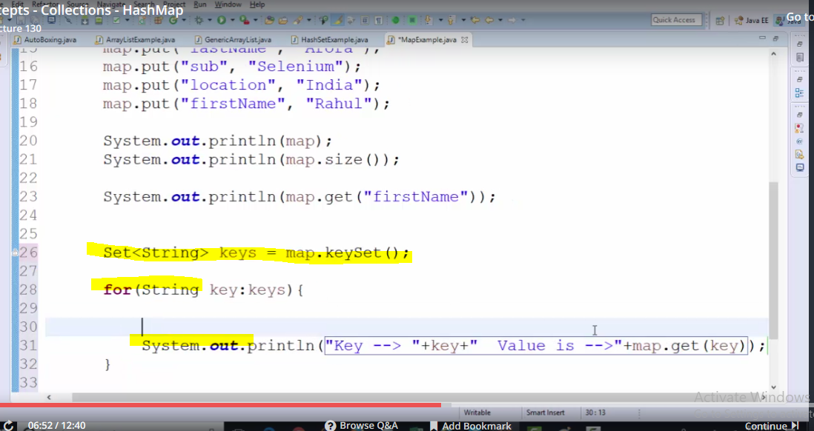

**Method 2: By iterating the hash map:**

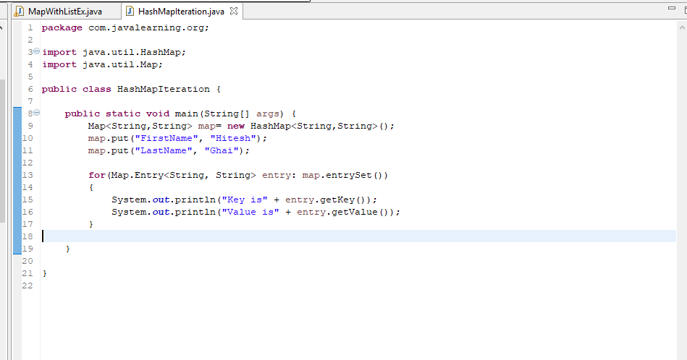

**How to assign a list to single key?**

